1. **Title of practice**

Capacity Building and Skill Development

1. **Objective of Practice**

The objective of the up skilling centre for cutting tailoring for women Entrepreneur at Bazipora and other skill programs of the centre is to enhance the trainee’s abilities and expertise, enabling them to contribute more effectively, enabling to their personal, growth, organization success & societal development. Centre for Capacity Building& Skill Development plays crucial role in empowering our beneficiaries/ trainees especially illiterate females from downtrodden area to reach their full potential and also fostering them for professional growth and driving overall progress. As its core, Centre for Capacity Building & Skill Development endeavor to empower youth, organization and communities with the knowledge and skills resource and to adapt innovation in economic environments.

Our primary objective is to strengthen institutional capabilities enabling organizational to effectively plan, implement and evaluate programme & initiatives by investing in training, mentorship and knowledge sharing. Centre for Capacity Building & Skill Development initiatives seek to enhance organizational effectively, effectiveness and sustainability.

Furthermore, Centre for Capacity Building& Skill Development introduce such skill courses which aims to foster a culture of continuous learning and innovation, empowering unemployed youth to acquire new skill and embrace emerging technologies and adapt to changing circumstance and introduce empowerment by skilling on large scale at Speed with high Standards and to promote a culture of innovation based entrepreneurship which can generate wealth and employment so as to ensure Sustainable livelihoods for all.

### 3. The Context

The traditional education system in India has primarily focused on textbook knowledge while less on developing vocational knowledge and practical skills. NEP 2020 seeks to change this scenario by shifting the paradigm from a rote-based academic approach to a skill-based education system as it recognises the importance of vocational education and equips students with the necessary skills to thrive in a rapidly evolving job market.

NEP 2020 aims to integrate vocational education into mainstream education as students can pursue vocational courses alongside their regular academic courses. It also aims to combine theoretical knowledge with practical skills, making the student’s job ready and face life challenges.

### FLEXIBILITY AND CHOICE

With NEP 2020, students are encouraged to choose subjects based on their interests and aptitudes. The programme allows students to select vocational courses according to their interests and enables them to pursue their passions. It also aims to develop specialised skills among students in a variety of fields, such as finance, healthcare, tourism, engineering, and more.

### SKILL DEVELOPMENT CENTRES

As part of the mandate, skill development centres will be established as per the requirement and, training will be provided to the unemployed youth at these centres using state-of-the-art equipment, infrastructure, and resources. Through these centres, our centre aims to improve the quality of vocational education and make trainees future-ready to make them self reliant.

**4. The Practice**

With the rollout of the National Educational Policy (NEP) in 2020, there has been a renewed focus on vocational skill training imparted by schools and higher Education Institutes, thus integrating mainstream academics with practical vocational skill training.

Skill development is a critical aspect of life, involving the development of specific skill sets according to one’s goals. These skills help us grow in our personal and professional lives, which is especially important for employment and professional growth, especially after completing 12th grade. As we live in the fourth industrial age, employability skills are essential for obtaining employment, connecting with coworkers, performing better, and making responsible choices in the workplace. In this digital world, there are numerous courses available to enhance an individual’s capabilities.

Skill development is the process of improving specific skills to be more efficient and effective when you perform a task. In the workplace, you'll find three main types of skill development: Up skilling: Improving your skills in your current role. Cross-skilling: Learn new skills for your current role.

Skills Development refers to the process of acquiring, improving, and enhancing a wide range of skills and competencies. It involves the deliberate and continuous effort to build knowledge, expertise, and capabilities in specific areas to meet the demands of one's work or to pursue personal and professional growth.

### CONTINUOUS SKILL UPGRADATION

NEP 2020 emphasises the need for continuous skill gradation to ensure that vocational education remains relevant in the rapidly evolving job market. By staying abreast of the changing landscape, vocational education can remain responsive to the demands of the industry and equip students and trainees with the latest skills required for employment.

Our centre has given due importance to vocational education, and capacity development of instructors and trainees to boost the employability skills and vocational skills of the learners at all levels. Quality of VET is to be enhanced by identifying, designing and development of vocational courses that meet the common norms and skills standards identified at the national level will hold a new era for vocational education in India. By giving due importance to vocational education and integrating it into mainstream learning, the policy aims to empower students.

Good practice in skill development can be limited by factors such as time constraints, access to resources, individual aptitude, and the quality of instruction or feedback. Additionally, personal motivation and consistency play crucial roles in skill improvement.

Constraints in good practice under skill development can include:

1. **Time Constraints:** Limited time available for practice sessions can hinder skill development progress.
2. **Resource Limitations:** Access to quality training materials, equipment, or facilities may be restricted, impacting the effectiveness of practice.
3. **Individual Aptitude:** Each person has their own learning curve and innate abilities, which can affect how quickly they can develop a skill.
4. **Quality of Instruction:** The availability of skilled instructors or mentors can vary, affecting the guidance and feedback received during practice.
5. **Environmental Factors:** Distractions or unsuitable practice environments can impede concentration and hinder skill acquisition.
6. **Motivation and Persistence:** Lack of motivation or consistency in practice can slow down progress, even with access to resources and instruction.
7. **Physical Limitations:** Some skills may require physical capabilities beyond an individual's current capacity, necessitating additional training or adaptations.

[bandipora](https://src.uok.edu.in/Main/Gallery.aspx?Gallery=56c31fab-4130-4ec1-a29d-727a83e9ed28)

**5. Evidence of success**

**Capacity Building Programmes for the Ministerial Staff of KU**

The Centre for Capacity Building & Skill Development University of Kashmir took an initiative by organizing a one day orientation programme for a group of 50 Ministerial staff of the University of Kashmir on work ethics at Conference Hall Gandhi Bhawan. The aim of the programme was to orient the participants’ awareness and information on various issues related to work ethics among the working staff.

This programme was found very much successful which is evident by the overwhelming response of the participants who insisted for organization of similar programmes on large scale to cover the other staff member for longer durations and coverage of other topics like finance management skills and other issues relevant to their work profile. Prof Nazir Ahmad, HOD Commerce, Dr. Irshad IMHANS, Psychiatrist, Prof. Shazia Manzoor, Social Work, Prof Humaira Shafi, Deptt of Psychology and Mr. Mohamad Yousuf Project Officer were among the Resource persons who were invited to deliberate upon various topics such as leadership qualities, stress management, team work, work ethics and effective communication. The programme was concluded by distribution of certificates.

[link1](https://src.uok.edu.in/Main/Gallery.aspx?Gallery=f358fa22-7130-4711-a378-0c94ab6df983):

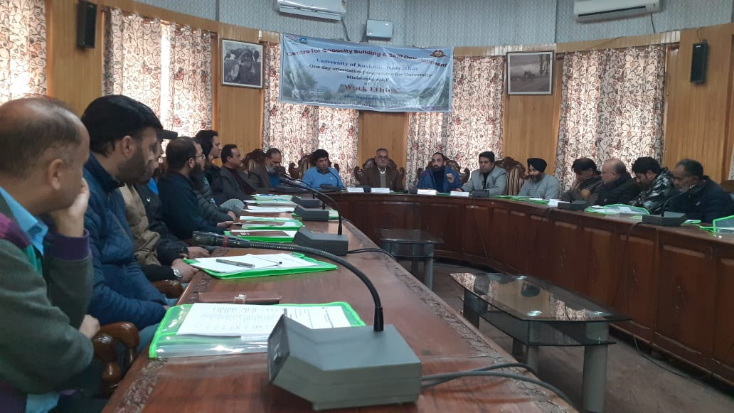

**Capacity Building Programmes for the Ministerial Staff of KU**

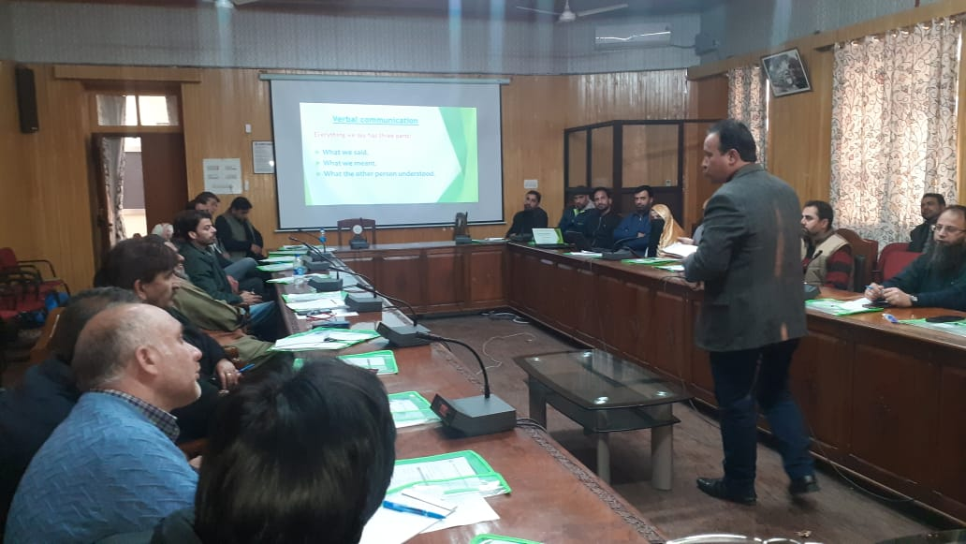

**Skill Development Programme at community level**

The Centre has been established as **Centre for Capacity Building & Skill Development (CCB&SD)** by the University of Kashmir on 19th April 2023 by renaming erstwhile SRC which is having its administrative and academic control of the University and is manned by One Coordinator and academic faculty. The faculty consisting of 2 project Officers and one Programme Associate to organize and conduct orientation/Training for various categories of staff pertaining to organizations & Institutions and to conduct skill development programmes on different Courses for the youth of Kashmir The mission of the Centre is to provide human resource development support to the in-service as well as to provide the skilled life to the students and youth to lead a better productive life in future.

Establishment of skill development centers like Up skilling Centre for Cutting & Tailoring for women entrepreneurs at Bazipora is one of the best practice made with the collaboration of Small Industries Development Bank of India SIDBI.

The centre has provided training to 25 BPL and tribal women of the village Bazipora who were also provided with 25 Sewing machines for each donated by DIDBI to encourage the trainees to earn their livelihood and form SHGs in the local area. There is enormous scope to replicate the same in other districts also on the same pattern.

**6. Problems Encountered and Resource Required**

The Centre has been newly established with a new mandate of Capacity Building and Training which is of a greater significance in the present day scenario of the developing society. Moreover it may not be out of place to mention that a paradigm shift has taken place and now the youth prefer to be more self reliant and skilled to show their existence in the fast changing life. The Government of India is also focusing on the on Skill India moment to empower the youth so that the country shall compete with other developed nations. In this context the Centre requires a sound concurrent financial assistance for these programmes which shall be carried out to achieve the set goal of the centre.

The skill programmes conducted in far flung areas at community level are more challenging as compared to the programmes at institutional level. May it be the monitoring, supervision or the resources like venue, infrastructure, and availability of Trainees, trainers or the other resource persons. However it is only possible with sufficient source of funding, resources and assistance of other allied institutions like Rural development, education department etc to execute the programme at field level. In order to overcome these challenges there should be strong support, networking and collaboration of other institutions as well.

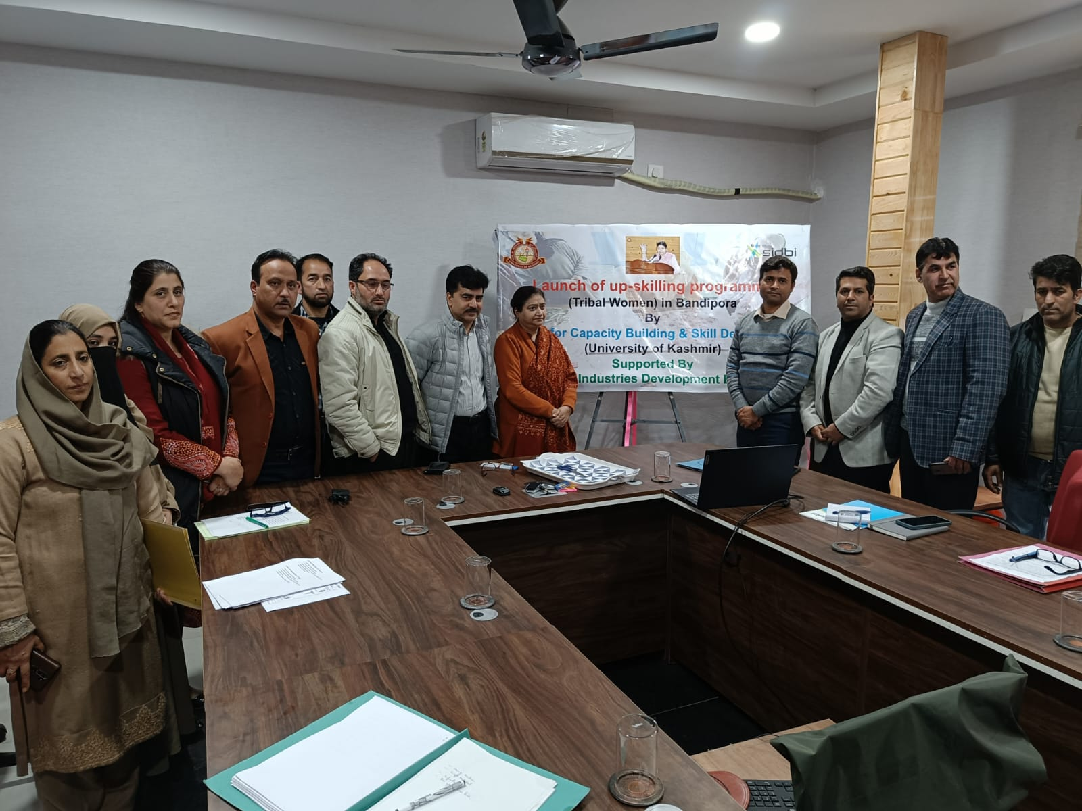

**Online Inauguration of up skilling Centre by Hon VC, KU**

